Planapps Installation and Upgrade Guide v4.1.0.0

Contents
1 Document Control 3
1.1 Author 3
1.2 Document Summary 3
1.3 Document History 3
1.4 Reference documents 3
1.5 Distribution 3
1.6 Quality Assurance 3
2 Introduction 4
2.1 Pre-requisites 4
3 Planapps Software Files 5
3.1 Implementation of the Planapps Software files 5
3.2 Pre-Requisites to Installation/Upgrade 6
4 Install APEX 3.2.1 10
4.1 Change the Password for the ADMIN Account 11
4.2 Unlocking the APEX_PUBLIC_USER Account 11
4.3 Copy the Images Directory 12
4.4 Editing the dads.conf 13
4.5 Obfuscating PlsqlDatabasePassword Parameter 14
5 Planapps Server Install/Upgrade 15
5.1 Implementation of the Planapps Software files 15
5.2 Planapps Server Install/Upgrade 16
5.2.1 Before you Start 16
5.2.2 Typical problems that you may encounter 16
5.2.3 Install/Upgrade of Planapps 16
5.2.4 Checking Log File(s) 17
5.2.5 Importing the Planapps ApEx Application 18
5.2.6 Export the NLPG tables 20
5.2.7 Product Licencing 20
5.2.8 MapViewer 21
5.2.9 Set up the themes 21
5.2.10 PLAURL Product Option 21
5.2.11 Create The MetaData 21

- Document Control
  - Author
Exor Development

  - Document Summary
This document provides instructions on the Installation or upgrade of Planapps to version v4.1.0.0.

  - Document History

Document History
Revision | Date | By | Description
3.0 | 01-Feb-2010 | Exor Development | First Edition
3.1 | 25-Feb-2010 | Exor Development | Second Edition

  - Reference documents
None

  - Distribution
Exor Customers, Partners and Staff

  - Quality Assurance
Document Details
File | Prepared By
0000.doc | Exor Development
Document Name | Reviewed By
0000.doc | Andy Rowlinson/Mark Lowe
Version | Approved for issue by
3.1 | Colin Stewart
Date of Issue | Support Manager
26-Feb-2010 | Graham Anns

- Introduction
This document will guide you through the installation/upgrade and configuration of Planapps.

  - Pre-requisites
Your highways system must, at least, be at version 4.1.0.0 as a base line and have Enquiry Manager installed.

The version of application express must be at 3.2.1 This can be downloaded from Oracle at http://www.oracle.com/technology/products/database/application_express/download.html
Installation or upgrade is covered in this document.

An excellent knowledge of databases, SQL. PL/SQL, sqlplus and a command prompt are expected from the installer.

- Planapps Software Files
  - Implementation of the Planapps Software files

To install the software components for Planapps execute the setup_planapps_4100.exe and follow the on-screen prompts.

When the wizard completes, the necessary client and server software files will have been installed.

Notes:
A password is required to be entered during this process. If you are not sure of the password contact support@exorcorp.com.

Important:
All exor applications that you install must go into the same destination – what is often referred to as <exor_base>.

To support different roll-out models, you can decide to just install Client or Server or both sets of components into the <exor_base>.
  - Pre-Requisites to Installation/Upgrade
It is assumed that the audience of this document understand the configuration of the servers being installed/upgraded and are sufficiently proficient with SQL*Plus. It is also assumed that the terminology used in this document is understood by the reader.

NB. The instructions for installation of the software describes the installation of all the software into a single area (usually referred to as the ‘Client’). The instructions for upgrading the Server (your Highways schema) assume you have access to the database from the ‘Client’.

Your configuration and server access may differ from this; the InstallShield can still be used for installation. For example, you may have to install the Client software on the Application Server and the Server software on the Database Server for reasons of database access availablilty from the Application Server.

If in any doubt please contact support@exorcorp.com.

Before attempting to upgrade, you should ensure that;

- the appropriate software components are installed and are compatible with the exor certification matrix. The certification matrix can be downloaded from the Client area of the exor website.

- all users are disconnected from the system

- the highways listener processes are not running

- a database export of the owner of Highways owner has been taken.

- You MUST copy the current <exor_base> directory and sub-directory structure and contents to a new area (e.g. <exor_base4050>). This ensures that a copy is available for backup or reference purposes should any issues arise during the installation.
The installation can then continue into a new area (e.g. <exor_install4051>) which should then be copied onto the <exor_base>.

For Example:
….copy the current <exor_base> directory and sub-directory structure and contents to a new area (e.g. <exor_base4050>)

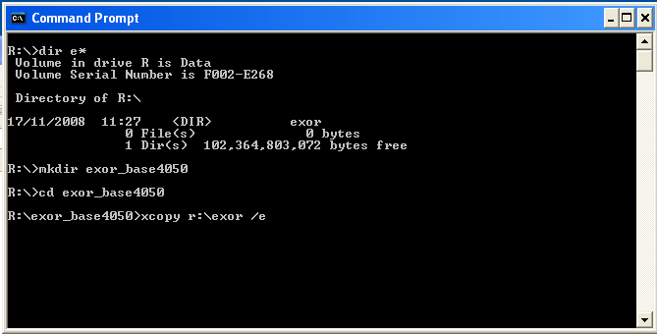

… The installation can then continue into a new area (e.g. <exor_install4051>)

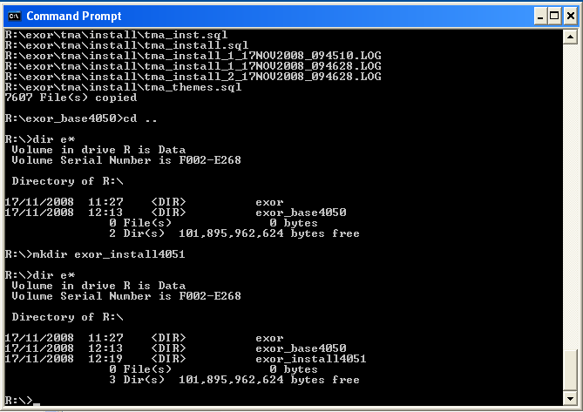

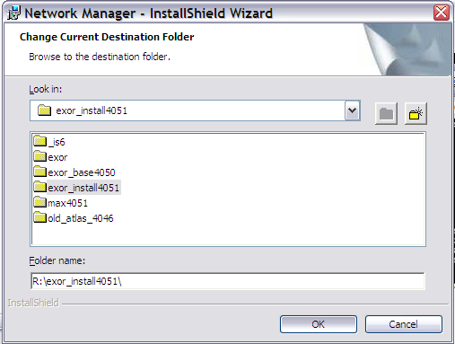

… which should then be copied onto the <exor_base>

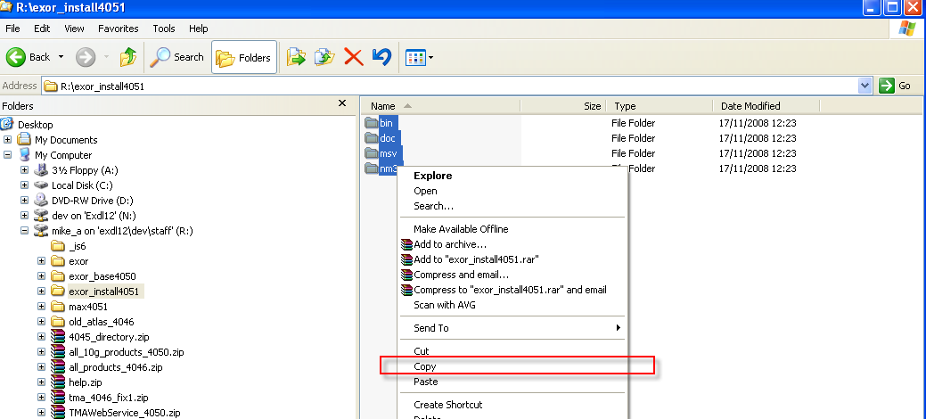

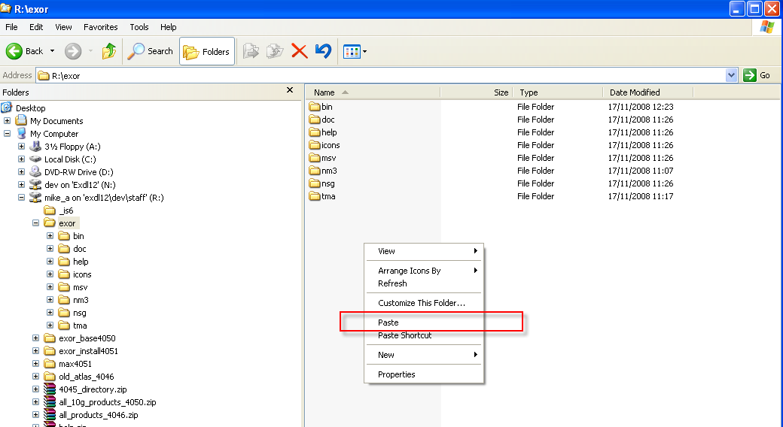

- Install APEX 3.2.1

You will need to create a tablespace to install APEX into.

Check if a tablespace exists.
select a.tablespace_name, (b.bytes/1024)/1024 Mb, b.file_name
from dba_tablespaces a
, dba_data_files b
where a.tablespace_name = b.tablespace_name;

If there is a tablespace called APEX check that it is large enough. At least 500Mb.

As the sys user execute the following to increase the datafile size.
where ‘filename’ is the value returned from the query above eg
'D:\ORACLE\DATABASES\HAMPS\APEX.DBF'

alter database datafile ‘filename’ resize 2500M;

If you need to create an APEX tablespace.
Make a note of the path to the other datafiles listed above and use the following to create a tablespace.

CREATE TABLESPACE apex
DATAFILE
'path\apex01.dbf' SIZE 1024 m
AUTOEXTEND ON NEXT 1024 M MAXSIZE UNLIMITED;

Check that the apex tablespace exists using the query above.

Download the apex install package from http://www.oracle.com/technology/products/database/application_express/download.html

Unzip the package to a working directory c:\apex

What follows is extracts from the APEX install guide located in the working directory\apex\doc\install\e13366.pdf.
From the section Downloading from OTN and configuring Oracle HTTP Server.

This can be followed for an new install of apex or an upgrade from a previous version.

Start a command prompt, ( Start->Run and enter cmd)

Change directory to the location that you unzipped the apex package to.

Change directory until you can see the file apexins.sql

Start sqlplus and log in as the sys user.

Then
Run apexins.sql passing the following
four arguments in the order shown:
@apexins tablespace_apex tablespace_files tablespace_temp images
Where:
– tablespace_apex is the name of the tablespace for the Oracle
Application Express application user.
– tablespace_files is the name of the tablespace for the Oracle
Application Express files user.
– tablespace_temp is the name of the temporary tablespace.
– images is the virtual directory for Oracle Application Express images. To
support future Oracle Application Express upgrades, define the virtual
image directory as /i/.
Example:
@apexins apex apex TEMP /i/

When Oracle Application Express installs it creates three new database accounts:
■ APEX_030200 - The account that owns the Oracle Application Express schema
and metadata.
■ FLOWS_FILES - The account that owns the Oracle Application Express uploaded
files.
■ APEX_PUBLIC_USER - The minimally privileged account used for Oracle
Application Express configuration with Oracle HTTP Server and mod_plsql.
If you are upgrading from a previous release, FLOWS_FILES, already exists and
APEX_PUBLIC_USER is created if it does not already exist.

A log file is created, eg install2009-03-13_13-22-55.log review this for any errors.

  - Change the Password for the ADMIN Account

In a new installation of Oracle Application Express, or if you are converting a runtime
environment to a development environment, you must change the password of the
internal ADMIN account. In an upgrade scenario, the password will be preserved and
carried over from the prior release.
To change the password for the ADMIN account:
1. Change your working directory to the apex directory where you unzipped the
installation software.
2. Start SQL*Plus and connect to the database where Oracle Application Express is
installed as SYS specifying the SYSDBA role. For example:
■ On Windows:
SYSTEM_DRIVE:\ sqlplus /nolog
SQL> CONNECT SYS as SYSDBA
Enter password: SYS_password
■ On UNIX and Linux:
$ sqlplus /nolog
SQL> CONNECT SYS as SYSDBA
Enter password: SYS_password
3. Run apxchpwd.sql. For example:
@apxchpwd
When prompted enter a password for the ADMIN account.

Configure the Oracle HTTP server.

  - Unlocking the APEX_PUBLIC_USER Account

The APEX_PUBLIC_USER account is locked at the end of a new installation of Oracle
Application Express. You must unlock this account before configuring the database
access descriptor (DAD) in a new installation.
To unlock the APEX_PUBLIC_USER account:
1. Start SQL*Plus and connect to the database where Oracle Application Express is
installed as SYS specifying the SYSDBA role. For example:
■ On Windows:
SYSTEM_DRIVE:\ sqlplus /nolog
SQL> CONNECT SYS as SYSDBA
Enter password: SYS_password
■ On UNIX and Linux:
$ sqlplus /nolog
SQL> CONNECT SYS as SYSDBA
Enter password: SYS_password
2. Run the following statement:
ALTER USER APEX_PUBLIC_USER ACCOUNT UNLOCK

Changing the Password for the APEX_PUBLIC_USER Account

The APEX_PUBLIC_USER account is created with a random password in a new
installation of Oracle Application Express. You will must change the password for this
account before configuring the database access descriptor (DAD) in a new installation.
To change the password for the APEX_PUBLIC_USER account:
1. Start SQL*Plus and connect to the database where Oracle Application Express is
installed as SYS specifying the SYSDBA role. For example:
■ On Windows:
SYSTEM_DRIVE:\ sqlplus /nolog
SQL> CONNECT SYS as SYSDBA
Enter password: SYS_password
■ On UNIX and Linux:
$ sqlplus /nolog
SQL> CONNECT SYS as SYSDBA
Enter password: SYS_password
2. Run the following statement:
ALTER USER APEX_PUBLIC_USER IDENTIFIED BY new_password
Where new_password is the new password you are setting for APEX_PUBLIC_
USER. You will use this password when creating the DAD in the sections that
follow.

  - Copy the Images Directory

The images directory need to be copied from the APEX working Directory(apexHome) to the http server

xcopy /E /I APEX_HOME\apex\images ORACLE_HTTPSERVER_HOME\Apache\apex\images

  - Editing the dads.conf

If you can access the dad via enterprise manager then edit the dad in the usual way.
If not follow these instructions.

Use a text editor and open the dads.conf

ORACLE_HTTPSERVER_HOME\Apache\modplsql\conf\dads.conf

In the dads.conf file, replace ORACLE_HTTPSERVER_HOME, host, port,
service_name, with values appropriate
for your environment.

Note that the apex_public_user_password is the
password you changed above
Note that the path listed is only an example. The path in the dads.conf file should
reference the file system path described in "Copy the Images Directory" .

These values might already exist
Alias /i/ "ORACLE_HTTPSERVER_HOME/Apache/apex/images/"
AddType text/xml xbl
AddType text/x-component htc

PlsqlDatabaseUsername should be the highways owner username

PlsqlDatabasePassword should be the password of the highways owner
<Location /pls/apex> this should be /<database_sid>/planapps

<Location /<database_sid>/planapps>
Order deny,allow
PlsqlDocumentPath docs
AllowOverride None
PlsqlDocumentProcedure wwv_flow_file_mgr.process_download
PlsqlDatabaseConnectString HOST:PORT:SERVICE_NAME ServiceNameFormat
PlsqlNLSLanguage AMERICAN_AMERICA.AL32UTF8
PlsqlAuthenticationMode Basic
SetHandler pls_handler
PlsqlDocumentTablename wwv_flow_file_objects$
PlsqlDatabaseUsername HIGHWAYS_OWNER
PlsqlDefaultPage apex
PlsqlDatabasePassword HIGHWAYS_OWNER_PASSWORD
PlsqlRequestValidationFunction wwv_flow_epg_include_modules.authorize
Allow from all
</Location>

Stopping and Restarting Oracle HTTP Server To stop and restart Oracle HTTP Server:

ORACLE_HTTPSERVER_HOME\opmn\bin\opmnctl stopproc ias-component=HTTP_Server
ORACLE_HTTPSERVER_HOME\opmn\bin\opmnctl startproc ias-component=HTTP_Server

  - Obfuscating PlsqlDatabasePassword Parameter

The password in the dads.conf is in clear text the following can be used to obfusticate it.
The PlsqlDatabasePassword parameter specifies the password for logging in to
the database. You can use the dadTool.pl utility to obfuscate passwords in the
dads.conf file. To obfuscate passwords, run dadTool.pl by following the instructions in the
dadTool.README file.

- Planapps Server Install/Upgrade
  - Implementation of the Planapps Software files

To install the software components for Maintenance Manager execute the setup_planapps_4100.exe and follow the on-screen prompts.

When the wizard completes, the necessary client and server software files will have been installed.

Notes:
A password is required to be entered during this process. If you are not sure of the password contact support@exorcorp.com.

Important:
All exor applications that you install must go into the same destination – what is often referred to as <exor_base>.

To support different roll-out models, you can decide to just install Client or Server or both sets of components into the <exor_base>.

  - Planapps Server Install/Upgrade

This chapter provides details of steps involved in installing/upgrading the server components for Planapps.

Important:
This product will require installing/upgrading after Enquiry Manager v4.1.0.0.

    - Before you Start

Before proceeding please ensure that the pre-requisites mentioned in Section 3.2 of this document are met.

Also, please be aware of the following;

Where instructed to change to a directory before running a script, it is assumed that you are running SQL*PLUS from a DOS Command prompt.

If you are running SQL*PLUS in windows you should set the 'start in' directory of the SQL*PLUS shortcut to simulate the change of directory.

If you do not run SQL*PLUS from the directory stated in each step of the guide, the installation will fail.

Also, whilst following the instructions in this section you will be required to know the location of <exor_base>. You may recall that whilst undertaking the tasks in Section 5.1 you will have implemented software into the location referred to as <exor_base>, for example, C:\EXOR.

    - Typical problems that you may encounter

It is possible that, when you are running some of the upgrade scripts, errors may be reported saying that objects already exist in the database or that columns already exist on tables. These errors can generally be ignored. If you are in any doubt, please contact the Exor support desk for guidance.

The upgrade procedures will also attempt to install database roles in the highways owner account that are necessary for the system to operate correctly. You may find that errors are produced when running the upgrade scripts to the effect that the role names being created are already used by existing roles or users. These errors can be ignored as they simply mean that the roles being created already exist.

Also during upgrade Warning messages may appear saying that compilation errors have occurred. These warnings can be ignored, since invalid objects will be recompiled prompt later on in the upgrade. However it will be of concern if compilation errors still occur following the re-compilation.

    - Install/Upgrade of Planapps

To create the base data and objects for Planapps modules;

Change directory to <exor_base>\pla\install

Login to SQL*PLUS as the highways owner on the client PC and run the following command:
start pla_inst

You will be prompted to enter the path of the location of your highways software. This should be name of the directory, including disk identifier and a trailing slash character, referred to as <exor_base>.

For example, if you installed your highways software in a directory called EXOR on your C drive, you would enter the following when prompted.

C:\EXOR\

When you have supplied this value, you will be prompted to confirm that it is correct and asked whether you wish to continue.

If the value specified is not correct or does not end with a slash character, you will be given an error message and the installation script will abort. You will then need to login to SQL*PLUS again and rerun the script.

When the script has completed, all the Planapps objects and data will have been installed/Upgraded.

    - Checking Log File(s)

The following log files are produced in the working directory. At the end of the installation/upgrade, the files can be viewed to check for any errors that could have occurred during installation.

The installation script determines whether the route taken should be to install/upgrade or apply fix.

Should an Install be performed (Planapps installed for the first time) the log files produced will be in the following format:

pla_install_1_<date&time>.LOG
pla_install_2_<date&time>.LOG

Should an upgrade be performed (Planapps has already been installed in a prior release) the log files produced will be in the following format:

pla4052_pla4100_1_<date&time>.LOG
pla4052_pla4100_2_<date&time>.LOG

Should a fix be performed (Planapps requires a patch to be applied on top of a release) the log files produced will be in the following format:

pla4100_fix<fix_version>_1_<date&time>.LOG
pla4100_fix<fix_version>_2_<date&time>.LOG

Log files should be emailed to support@exorcorp.com to allow exor support staff to verify the install has been successful.

Due to interdependencies between some Exor products, please ignore all compilation errors until all of your products have been upgraded.

    - Importing the Planapps ApEx Application

Log onto the ApEx user account that the Planapps application will be imported into.

Choose to Import Application:
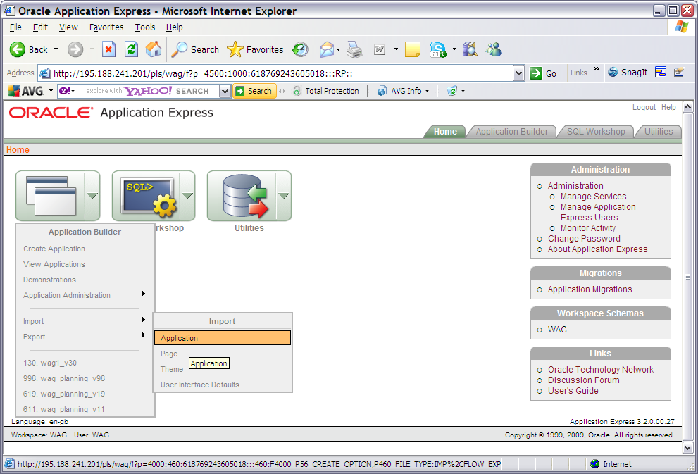

Browse for the SQL file with the previously extracted files 5.1 Implementation of Planapps Files. It will be called <exor_base>/pla/admin/sql/ f624_wag_planning_v24.sql. Once selected Click the next button
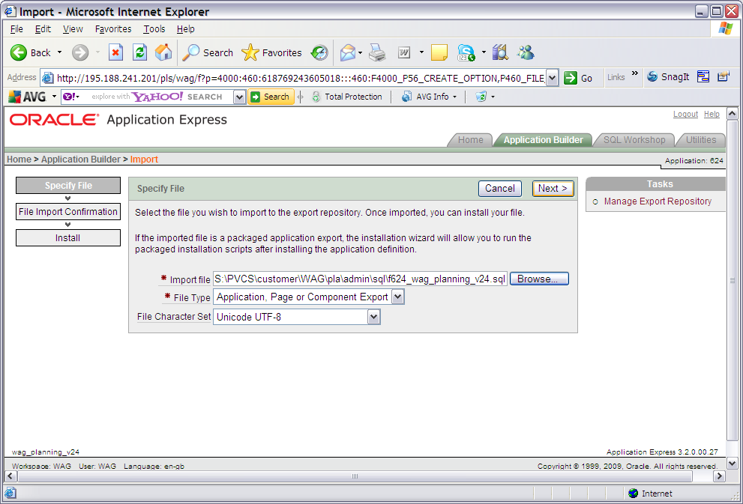

Once successfully Imported Click the Next button.
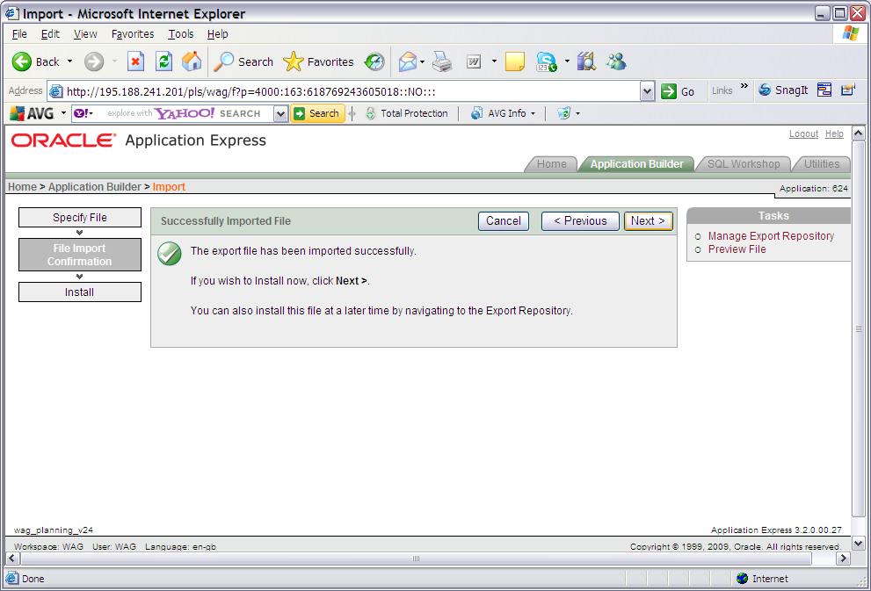

Select Parsing Schema as the Highways Schema, Build Status as ‘Run Application Only’ and select the ‘Reuse Application ID 624 From Export File’ option from the Install as Application Radio button options. Then click the Install button.
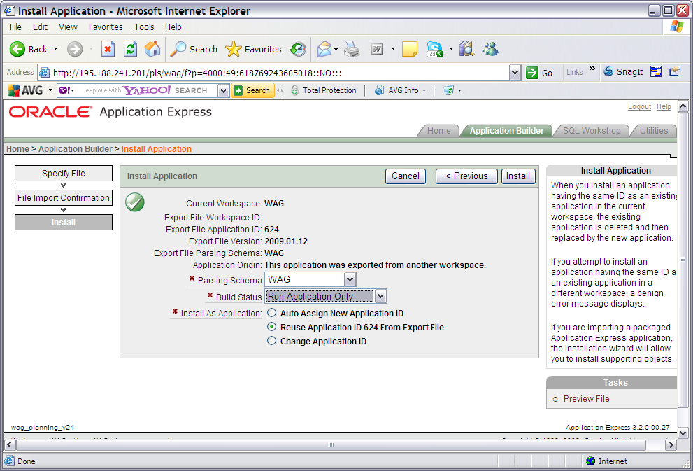

You should be met with this screen.
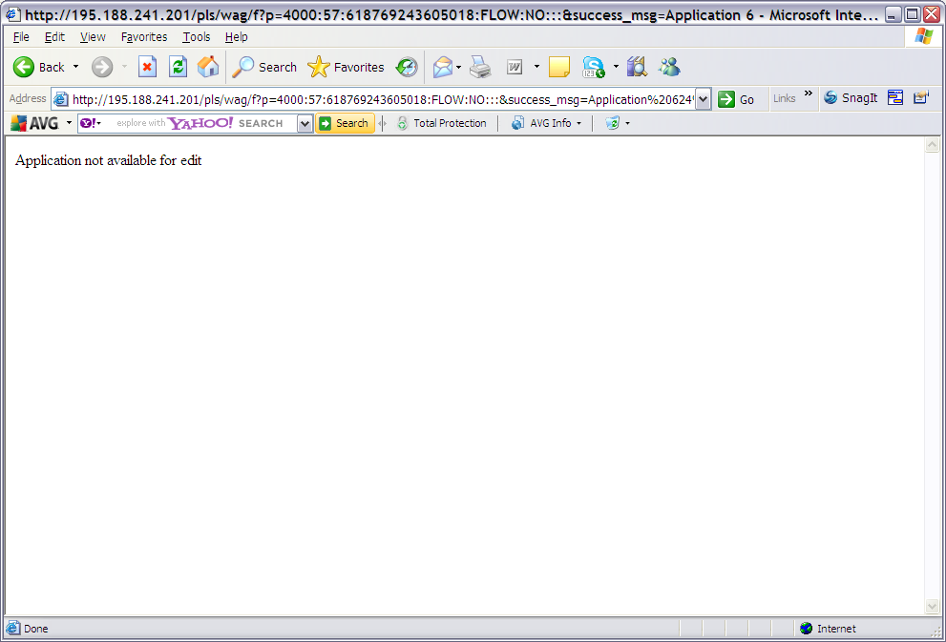

Planapps should be installed but as Run only meaning that the application cannot be edited.

    - Export the NLPG tables

The following tables exist on the sandbox that should be exported (with data) to Live.

NLPG_LPI
NLPG_STREET
NLPG_STREET_DESCRIPTOR
NLPG_BLPU

These tables hold the NLPG data that would ordinarily be handled by a Street Data loader. This loader does not exist in any official capacity so please export the data instead.

Please note that another table NLPG_DUMMY_PROPERTIES should be exported but without the data (or the data removed post export).

    - Product Licencing

Following first time installation you must licence the product for use.

To do this start highways by exor and invoke module HIG1890 from the Fastpath menu.

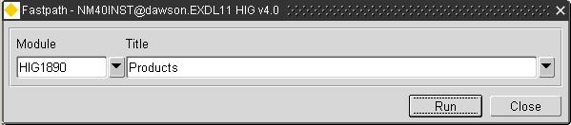
For further details please refer to the “Network Manager General System Admin Guide”

    - MapViewer

Refer to the section on deploying MapViewer in the Install and Upgrade Guide v4200.pdf. Deploy mapViewer as if it were being deployed for IM4 i.e. using the 10.1.3 mapviewer file.

Use the Ear file shipped with this build, called mapviewerVer11.1.1_B090224.ear, in the MSV folder.

    - Set up the themes

Set up the relevant themes required to view map data. There is an export available in the MSV folder to achieve this called wagsb_style_theme_map.dat.

    - PLAURL Product Option

Ensure that the ‘PLAURL’ product option is set. This should be done in a similar vein to WAGDEV and WAGSB where the ApEx Planapps App URL forms the string plus the required variables.

    - Create The MetaData

Ensure that the following metadata is set up in the PEM system:

CAT PLAN

CLASS Outline
Full
Preliminary
Not yet set

TYPE Article 10 (target 14 days)
Article 15 (target 28 days)
Not yet set (target 0 days)

Query back the WAGDEV/WAGSB counterparts to see the relationship and re-emulate on Live.

